2. Edge AI Classification and Intelligent Multi-Node Verification
2.1 Overview
The Edge AI layer performs real-time intrusion classification directly on field-deployed nodes. By executing inference locally, the system achieves low response latency, reduced communication overhead, and reliable operation in agricultural environments with intermittent connectivity. This layer transforms validated sensor events into actionable intrusion decisions.
2.2 Event – Driven Sensor Fusion
An event-driven sensing strategy is adopted to minimize power consumption. A PIR sensor (HC-SR502) provides the initial motion trigger, followed by thermal verification (Melexis MLX90640) to confirm the presence of a warm-blooded object. Let
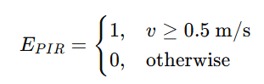
and thermal validation be expressed as
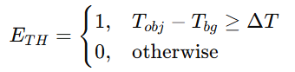
where $ΔT$is the adaptive thermal threshold. Image acquisition is triggered only when:
$$E_{final}=E_{PIR}∧E_{TH}$$This cascaded fusion significantly reduces false triggers and unnecessary image capture.

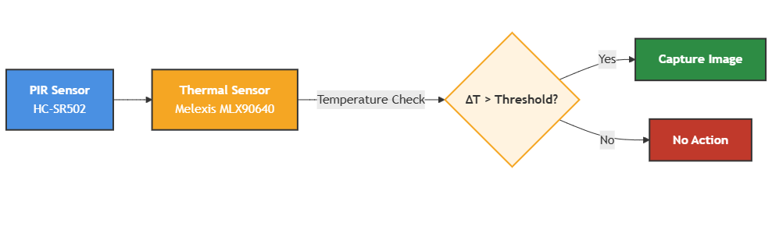
Figure 1: Event-driven sensor fusion workflow
2.3 Edge AI Model Deployment
The model is trained offline on annotated agricultural datasets and is quantized to 8-bit integer before being deployed to the edge. Quantization reduces memory usage and inference latency without significantly impacting the confidence of the classification. The model is deployed on the ESP32-CAM and performs inference in real time using TensorFlow Lite Micro.

2.4 On-Device Inference and Confidence-Based Decision Logic
The neural network outputs class probabilities using a Softmax or Sigmoid activation. For a multi-class case, the Softmax function is defined as:
$$P_{i}=\frac{e^{z_{i}}}{\sum_{j=1}^{N}{e^{z_{j}}}}$$where $P_{i}$represents the confidence score for class $i$. The detection decision is based on the maximum confidence value $C_{max}$:
$$C_{max}=max⁡(P_{1},P_{2},…,P_{N})$$Decision rules are defined as:
$$\text{Detection}=\left\{\begin{matrix}\text{Confirmed}, & C_{max}≥0.80 \\ \text{Verify}, & 0.70≤C_{max}<0.80 \\ \text{Rejected}, & C_{max}<0.70\end{matrix}\right.$$
2.5 Node-to-Node Networking and Cross-Verification
Neighbouring nodes cooperate to cross-verify detections using short-range sub-GHz LoRa communication (868/915 MHz). Lightweight peer-to-peer mode allows local verification and operation without requiring a gateway. If a detection occurs with intermediate confidence (0.70 ≤ C < 0.80), a concise verification request is broadcast to neighbours. Neighbours query their recent PIR and thermal activity within a temporal window,
|t_{i}-t_{j}|≤3 s
and return correlated triggers. If a neighbour correlates the detection, the event is considered an intrusion. This distributed cross-verification approach provides a compromise between false positives and communication/power consumption.
2.6 Communication, Reliability, and System Management
Intrusion alerts are sent on LoRaWAN Class A uplinks in the 868/915 MHz band. Each alert packet contains minimal metadata (node id, timestamp, class name, confidence score) and is encrypted using AES-128 at the LoRaWAN MAC layer. Received uplinks are sent by the gateway to the backend on MQTT over TLS. To cope with unreliable connectivity, nodes buffer detection events locally and retransmit them once connectivity is reestablished. Periodic status uplinks are sent with key health metrics such as battery voltage and link quality to detect and remotely fix issues. Power consumption is minimised by duty-cycling that reduces activity during low-risk intervals, and is battery-aware. Secure over-the-time updates make remote maintenance of firmware and model possible.

